**Module 10 – Single Page Application framework – React**

**2.ReactJS-HOL**

**What Are React Components?**

React components are the building blocks of a React app. Each component is like a small part of the UI. Components make the code reusable and manageable.

**Difference Between React Components and JS Functions**

| **Aspect** | **JavaScript Function** | **React Component** |
| --- | --- | --- |
| Purpose | Performs a task or calculation | Used to return JSX/UI |
| Return Type | Returns value (string, number, etc.) | Returns JSX (HTML-like content) |
| Syntax | Regular JS syntax | Function or class with JSX |
| Lifecycle Methods | Not applicable | Has lifecycle methods (if class-based) |

**Types of React Components**

React mainly supports two types of components:

1. **Class Component**
   * ES6 class
   * Uses render() method
   * Can use state and lifecycle methods
   * Needs to extend React.Component
2. **Function Component**
   * Just a JS function that returns JSX
   * With React Hooks, can also use state and effects
   * Shorter and simpler for most cases

**Class Component**

A class component is written using the class keyword and must include a render() method which returns JSX.

import React, { Component } from 'react';

class Home extends Component {

render() {

return <h2>Welcome to the Home page of Student Management Portal</h2>;

}

}

export default Home;

**Function Component**

Function components are simple JavaScript functions that return JSX.

function About() {

return <h2>Welcome to the About page of the Student Management Portal</h2>;

}

export default About;

**Component Constructor**

The constructor in a class component is used to initialize the component’s state and bind methods.

constructor(props) {

super(props);

// state initialization can go here

}

**render() Function**

The render() method is mandatory in class components. It returns the JSX that will be displayed on the screen.

**Create a react app for Student Management Portal named StudentApp and create a component named Home which will display the Message “Welcome to the Home page of Student Management Portal”. Create another component named About and display the Message “Welcome to the About page of the Student Management Portal”. Create a third component named Contact and display the Message “Welcome to the Contact page of the Student Management Portal”. Call all the three components.**

**Structure:**

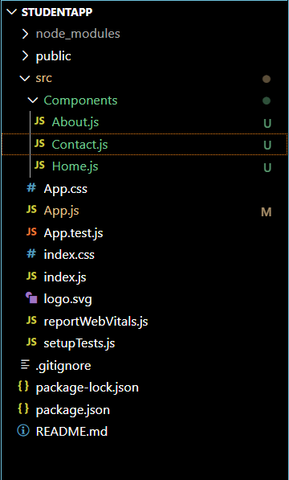

**About.js:**

import React from 'react';

function About() {

  return <h2>Welcome to the About page of the Student Management Portal</h2>;

}

export default About;

**Contact.js:**

import React from 'react';

function Contact() {

  return <h2>Welcome to the Contact page of the Student Management Portal</h2>;

}

export default Contact;

**Home.js:**

import React, { Component } from 'react';

class Home extends Component {

  render() {

    return <h2>Welcome to the Home page of Student Management Portal</h2>;

  }

}

export default Home;

**App.js:**

import React from 'react';

import Home from './Components/Home';

import About from './Components/About';

import Contact from './Components/Contact';

function App() {

  return (

    <div>

      <Home />

      <About />

      <Contact />

    </div>

  );

} export default App;

**Output:**

